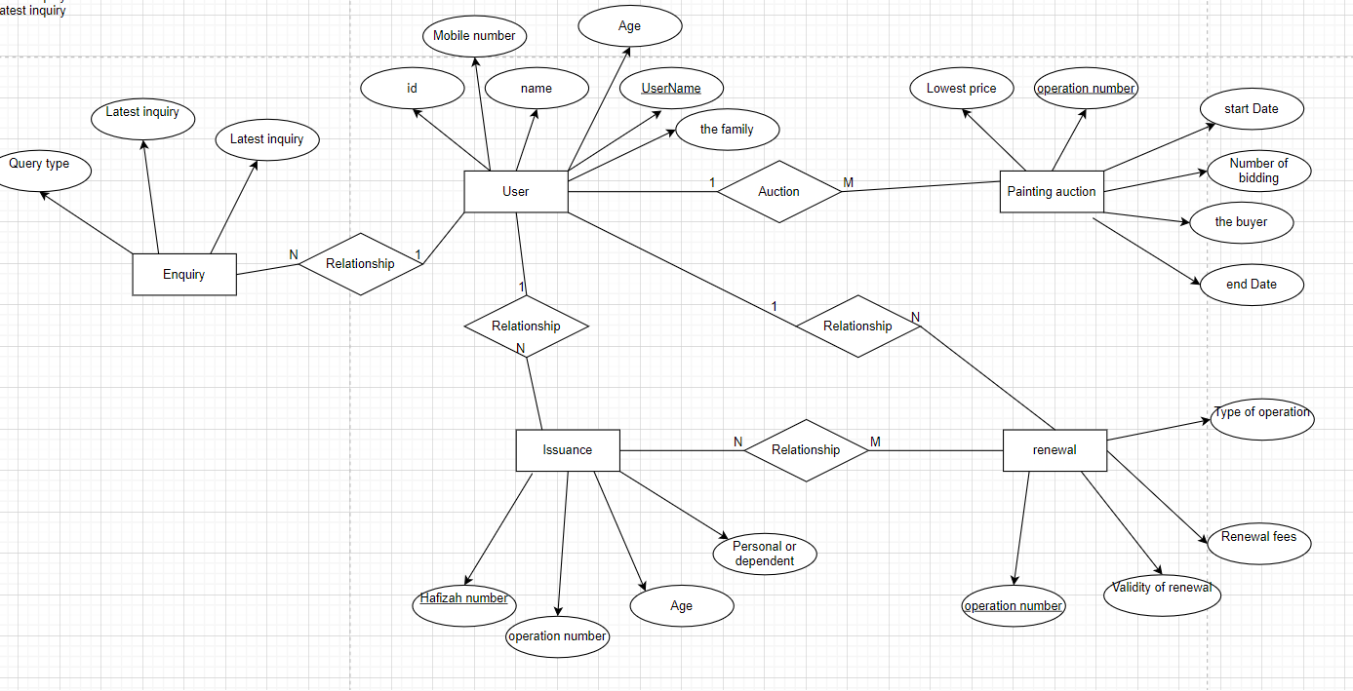

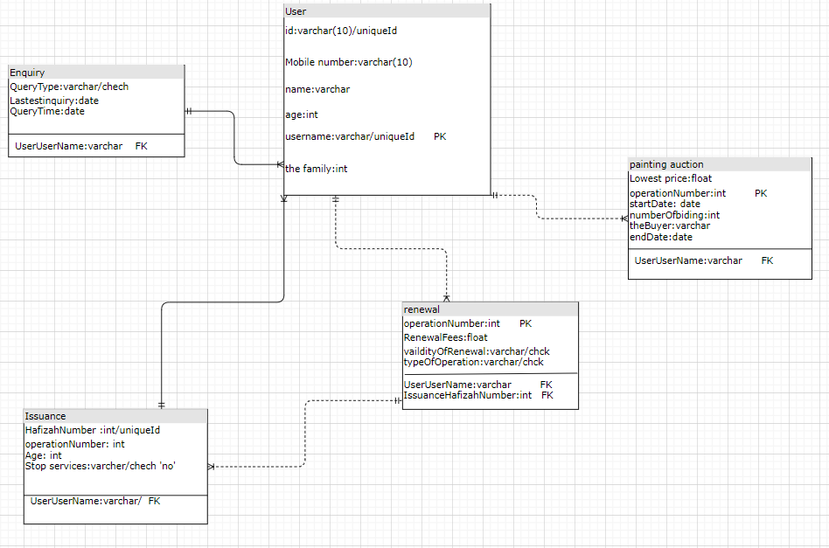

create database absher;  
create table user(  
id char(10)unique not null ,  
 mobileNumber char(10)not null ,  
 name varchar(25)not null ,  
 age int not null ,  
family’embers int not null ,  
 userName varchar(25)primary key not null  
);  
  
create table enquiry(  
 QueryType varchar(25),  
 LatestInquiry varchar(25),  
 QueryTime datetime,  
 userUserName varchar(25),  
foreign key (userUserName) references user(userName)  
);  
create table issuance(  
HafizahNumber int primary key ,  
 operationNumber int unique ,  
 stopServices varchar(2)check ( stopServices = 'no' ),  
 userUserName varchar(25),  
foreign key (userUserName) references user(userName)  
);  
create table renewal(  
 operationNumber int primary key ,  
 RenewalFees float,  
 validityOfRenewal varchar(3) check ( validityOfRenewal = 'yes' or validityOfRenewal ='no' ),  
typeOfOperation varchar(12) check ( typeOfOperation ='license' or typeOfOperation ='Proof' or typeOfOperation ='Permissible'),  
 IssuanceHafizahNumber int ,  
 userUserName varchar(25),  
foreign key (userUserName) references user(userName),  
foreign key (IssuanceHafizahNumber)references issuance(HafizahNumber)  
);  
create table paintingAuction(  
 LowestPrice float not null ,  
 operationNumber int primary key ,  
 startDate datetime,  
 NumberOfBids int ,  
 theBuyer varchar(25),  
 endDate datetime,  
 userUserName varchar(25),  
foreign key (userUserName) references user(userName)  
);  
insert into user values ('1104444446','0511111113','yousef',25,0,'yousef');  
insert into user values ('1024444447','0511111103','abdullah',37,0,'abdullah');  
insert into user values ('1111111111','0511111117','bander',31,0,'bander');  
insert into issuance values (55,14,'no','yousef');  
insert into renewal values (1,50,'no','Proof',55,'yousef');  
insert into paintingAuction values (550,5,*current_timestamp*,1,null,*current_timestamp*,'yousef');